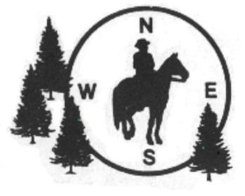
Tippecanoe River CMO
Friday, Saturday, Sunday
June 5-7, 2026
WHERE: Tippecanoe River State Park, 4200 N US-35, Winamac, IN 46996
Park Office : (574) 946-3213 Reservations can be made at reserveamerica.com
Approx 15 miles of nicely shaded, sandy trails, some rolling areas
FACILITIES: Water, pit toilets, hitching rails, fire pits, and picnic tables located throughout the horseman’s campground. There is a separate day use parking area with hitching rails and picnic tables

WHEN: All times are Eastern Daylight (Indiana) time
Friday, June 5: Individual instructions for riders, riders out 12 noon - no riders out 1 hour before sunset.
Saturday, June 6: Ride meeting starts at 10:00am. First riders out at 10:30am
Sunday, June 7: Ride meeting at 9:00am. First riders out at 9:30 am. No rider registration after 12 noon on Sunday. Times are flexible depending on conditions.
POTLUCK: Saturday 6:00 P.M. Ride managers will provide main course, please bring dish to share.
FEES: $12 per adult rider per day. $6 per Jr. Rider per day.
Non-members of NACMO will pay an additional $5 for a one-day membership to cover insurance each day.
CMO is a timed event covering from 5 to 15 miles in which you find 5-10 markers using a map (provided) and a compass. Riders can compete either individually or in teams. You will need an orienteering type compass (example – Silva 7), available wherever camping supplies are sold. Ride at any pace you like. We will provide instructions and a practice marker before each ride.
RIDE MANAGERS: Pam Martin 574-320-7909
Barb Brettnacher 765-427-2323

