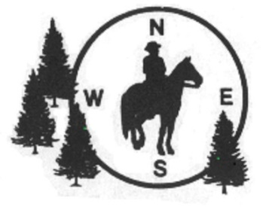

**Tippecanoe River CMO**

**Friday, Saturday, Sunday**

**April 25-27, 2025**

**WHERE: Tippecanoe River State Park, 4200 N US-35, Winamac, IN 46996**

**Park Office : (574) 946-3213 Reservations can be made at reserveamerica.com**

**Approx 15 miles of nicely shaded, sandy trails, some rolling areas**

**FACILITIES:Water, pit toilets, hitching rails, fire pits, and picnic tables located throughout the**

**horseman’s campground. There is a separate day use parking area with hitching**

**rails and picnic tables**

**WHEN:**  **All times are Eastern Daylight (Indiana) time**

**Friday, April 25, 2025:** Individual instructions for riders, riders out 12 noon - no riders out 1 hour before sunset.

**Saturday, April 26, 2025:** Ride meeting starts at 10:00am. First riders out at 10:30am

**Sunday, May 16, 2021:** Ride meeting at 9:00am.  First riders out at 9:30 am. No rider registration after 12 noon on Sunday. Times are flexible depending on conditions.

**POTLUCK: Saturday 6:00 P.M.  Ride managers will provide main course, please bring dish to share.**

**FEES:**   $12 per adult rider per day. $6  per Jr. Rider per day.

Non-members of NACMO will pay an additional $5 for a one-day membership to cover insurance each day.

CMO is a timed event covering from 5 to 15 miles in which you find 5-10 markers using a map (provided) and a compass. Riders can compete either individually or in teams. You will need an orienteering type compass (example – Silva 7), available wherever camping supplies are sold. Ride at any pace you like. We will provide instructions and a practice marker before each ride.

**RIDE MANAGERS:** Pam Martin 574-320-7909

 Barb Brettnacher 765-427-2323